Date : 10 October 2023
Mailing Add:
Macpherson Road Post Office PO Box 1083 Singapore 913412
Tel: 6748 8306
Email: info@spm.sg

Dear All SPM Members and Supporters

SOCIETY OF PROJECT MANAGERS SINGAPORE
SEMINAR & BOOK LAUNCH OF “CONSTRUCTION ARBITRATION” BY MR CHOW KOK FONG

We are thrilled to invite you to the highly anticipated book launch of Mr Chow Kok Fong’s latest masterpiece on construction arbitration. As one of the most renowned authors in the field of Construction Law, Mr Chow Kok Fong has enlightened readers with his insightful perspectives and extensive knowledge.

The event promises to be an exciting launch, as we bring together an esteemed panel of speakers to delve into the topical issues surrounding arbitration. This distinguished panel consists of leading experts and practitioners, will engage in thoughtful discussions, providing valuable insights and sharing light on the contemporary issues and challenges faced by the arbitration community.

Date : 17 November 2023 Time : 8.30 am to 2.00 pm
Venue : JW Marriott Singapore South Beach

The book will be reviewed by Mr Edwin Lee, Founding Partner, Eldan Law LLP. In addition to Mr Chow Kok Fong, our panel of speakers will include :
- Mr Ho Chien Mien; a Senior Accredited Specialist in Building and Construction Law and Co-Head of Construction and Engineering Practice in Allen & Gledhill

- Mr Kirindeep Singh; a Senior Accredited Specialist in Building and Construction Law and Senior Partner in Dentons Rodyk, Co-Head of the firm’s Construction practice.

- Mr Edwin Lee Peng Khoon; a Senior Accredited Specialist in Building and Construction Law and one of the Founding Partners of Eldan Law LLP and a Senior Specialist in Construction Law.

- Mr Ian De Vaz, a Senior Accredited Specialist in Building and Construction Law and Head of WongPartnership’s Infrastructure, Construction & Engineering Practice.

Page 1 of 2

Mailing Add:
Macpherson Road Post Office PO Box 1083 Singapore 913412
Tel: 6748 8306
Email: info@spm.sg

- Ms Yvonne Foo; a Partner in Harry Elias Partnership LLP’s Specialist Construction and Engineering and, Energy and Infrastructure practice groups.

We cordially invite you to join this book launch and be part of the conversation shaping the future of arbitration. This event offers a unique opportunity to gain profound insights, network with like-minded professionals and celebrate another milestone in Mr Chow Kok Fong’s books in construction law.

Attractive rates are set out in the flyer attached. The discounted rate will be valid until 17 November 2023 only.

Please RSVP by 10 November 2023 to secure a place at this exclusive event. Dress code for the occasion is business attire. Lunch will be served.

We look forward to welcoming you to the book launch and sharing our stimulating discussions and networking.

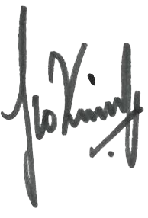
Warm regards,

Bernard Ho President
15th Council (2023/2025)
Society of Project Managers Singapore

Page 2 of 2

200 Braddell Road
BCA Academy, Block H, Level 2, Singapore 579700
Tel: 6748-8306
SEMINAR & BOOK LAUNCH OF “CONSTRUCTION ARBITRATION”
BY MR CHOW KOK FONG
(SPM CPD: 4 Points / SISV CPD: TBA / PEB PDU: 3 Points / BOA-SIA CPD: 2 Points)

Please register the following
 | places for SPM fellows and members @ S$ 210.00 each | S$
 | places for CIJC Members @ S$ 220.00 each | S$
 | places for non-member guests @ S$ 230.00 each | S$
 | places for participants who had purchased book from Sweet & Maxwell @ S$ 200.00 each | S$
 | Total | S$

I enclose a cheque (bank & cheque no.) for S$ made payable to "Society of Project Managers". I accept that the amounts paid are non-refundable in the event that I withdraw or otherwise amend this booking.

NAME
COMPANY
ADDRESS
CONTACT | (Office) | (Handphone)
NUMBERS: | (Fax) | (Others)

(If paying for participants beside yourself, kindly list their names in the list below)

Please return this form with remittance not later than 5pm on 10 November 2023 to the following:
Email: apm@spm.sg; chris.yongyc@sipmconsultants.com; luqman.ismail@sipmconsultants.com Address: Surbana Jurong Campus, 38 Cleantech Loop, #01-31, Singapore 636741
Attention: Mr Chris Yong / Mr Luqman Hakim / Ms Cari
Tel: 6748 8306 / 98278701 (Chris) / 91760699 (Luqman)

Payment methods
- PayNow to UEN (Entity Name: Society of Project Managers)
Please make payment to UEN S94SS0100J.
Kindly indicate your name/company name as reference and send us a copy of the transaction details together with this slip to apm@spm.sg; chris.yongyc@sipmconsultants.com; luqman.ismail@sipmconsultants.com

- Internet Banking Transfer
Please make payment to DBS Current Account 001-054-0840.
Kindly indicate your full name/company name as reference and send us a copy of the transaction details together with this slip to apm@spm.sg; chris.yongyc@sipmconsultants.com; luqman.ismail@sipmconsultants.com

- Cheque
Please make your crossed cheque payable to “Society of Project Managers”.
Kindly indicate your name and contact at the back of the cheque and mail it together with this slip to Macpherson Road Post Office, PO BOX 1083 Singapore 913412.

Registration (Sample)
S/N. | Name | HP No. | Office Tel No. | SPM Member/Associate | Remark
1
2
3
4
Please note that invoice will be generated upon request.

EVENT DETAILS
17 November 2023

JW MARRIOTT SINGAPORE SOUTH BEACH 8.30AM – 2.00PM
This event is sponsored by:

PROGRAMME
Time | Event
8:30am to 9.00am | Registration
9.00am to 9.05am | Welcome Address by President of SPM
9.05am to 9.20am | Official Book Launch & Speech by Guest of Honour
9.20am to 9.30am | Remarks by Mr Chow Kok Fong
9.30am to 9.40am | Book Review  Review of the newly launched book: “Construction Arbitration”  Mr Edwin Lee  Founding Partner, Eldan Law LLP
9.40am to 10:00am | Session 1: “(TBD) Managing Documents in Construction Arbitrations”  Finding the documents needed in construction arbitrations can sometimes be as time- and effort-consuming as finding proverbial needles in a haystack. Is there such a thing as ‘pain-free’ discovery? This session explores the various issues which different participants in the arbitration process would focus on at the discovery stage and whether the document collation process can be streamlined.  Mr Kirindeep Singh  Senior Partner, Dentons Rodyk & Davidson LLP

Time | Event
10.00am to 10.30am | Coffee Break
10:30am to 10:50am | Session 2: “Using CFAs to create Win-Win-Win situations”  The advent of litigation funding in Singapore has piqued the interest of many, particularly claimants with concerns about the potentially high costs of arbitration. How do commercial funding agreements (“CFAs”) work, and how do you make them work for you? This session looks at harnessing the benefits of litigation funding, and how it can be used to create a ‘win-win’ win situation for parties and their lawyers.  Mr Edwin Lee  Founding Partner, Eldan Law LLP
10.50am to 11.30am | Session 3: “Expertly engaging experts”  Experts have often played a substantial role in the conduct of a construction arbitration, and their testimony can be pivotal in the outcome of the arbitration. This discussion seeks views from those with the expertise in engaging experts on how to get the best value for money from this invaluable resource.  Mr Ho Chien Mien  Partner, Allen & Gledhill LLP  Mr Ian De Vaz  Partner, WongPartnership LLP
11:30am to 12:20pm | Session 4: Panel Discussion  Mr Chow Kok Fong & Panel Speakers  Have you ever had any questions about construction arbitration? This is the time to ask them and to get first-hand insight from our speakers and our author, Mr Chow Kok Fong!
12:20pm to 12.30pm | Presentation of Tokens of Appreciation
12:30pm to 2.00pm | Lunch

SPEAKER PROFILES
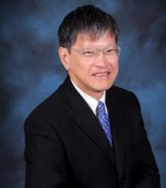  Chow Kok Fong  Founding President  Society of Project Managers  Author  Construction Arbitration | Mr Chow Kok Fong, PBM is a Chartered Arbitrator and a Fellow of the International Academy of Construction Lawyers. He was previously CEO of Changi Airports International and the Construction Industry Development Board and has held other senior appointments with major construction and real estate companies. He founded the Society of Project Managers and was past Chairman of the Society of Construction Law. Among his 21 books are Law and Practice of Construction Contracts (5 editions); Security of Payments and Construction Adjudication (3 editions) and the volume on building and construction law of Halsbury’s Laws if Singapore. He chaired the Ministry of Law working group drafting the Singapore Infrastructure Dispute Protocol which was published in 2018. He was awarded the Singapore Academy of Law Merit Award 2013 for contributions in promotions and advancing the development of Singapore law.
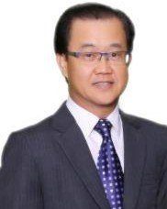  Bernard Ho  President  Society of Project Managers | Mr Bernard Ho is the Managing Director of SIPM Consultants Pte Ltd, and the current President of Society of Project Managers. He also holds multiple positions including Member of the Construction Industry Joint Committee, Member of iBuildSG Tripartite Committee and Committee Member, Member of Workplace Safety & Health Council (Construction & Landscape) Committee and Member of Singapore Business Federation Built Environment Sector IC Committee. His expertise is in project management, project development, IT and special complex projects. His market sector experience includes healthcare, commercial, residential, hospitality, entertainment, sports and leisure, industrial, mixed development and petrochemical projects. In addition, Bernard has vast experience in resolving numerous project dispute cases and many years of global and regional project management experience.
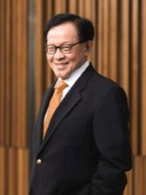  Seah Choo Meng  Senior Advisor  Meinhart (Singapore) Pte Ltd | Mr Seah Choo Meng is Senior Advisor to Group Chairman and CEO, Meinhart (Singapore) Pte Ltd. He is also concurrently Chairman and Director of METAV Cost and Contracts Management (MCCM), and Board Member, Group’s Global Board, Meinhart (Singapore) Pte Ltd.  Prior to his current appointments, Choo Meng served as Chairman of Threesixty Cost Management Pte Ltd, and Chairman of Threesixty Contract Advisory Pte. Ltd in Surbana Jurong Group. He was Chairman and Director of Langdon & Seah Singapore Pte Ltd, and Arcadis Project Management Pte Ltd with 45 years of service, stepping down in 2008.  Choo Meng was previously Council Chairman of the Singapore Institute of Surveyors and Valuers, as well as its Past President. He was also the Immediate Past President of the Society of Project Managers.
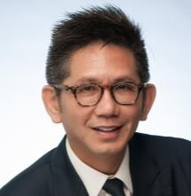  Ho Chien Mien  Partner, Co-Head of Construction & Engineering Practice  Allen & Gledhill LLP | Mr Ho Chien Mien is Co-Head of Allen & Gledhill’s Construction & Engineering Practice. Chien Mien’s contentious work involves litigation, arbitration, adjudication and mediation work relating to power, utilities, desalination, petrochemical and manufacturing plants, water treatment facilities, roads and tunnels, dams and waterways, mass rapid transit projects, sports complexes, aircraft hangars, major office buildings, retail malls, hotels, condominiums and specialised warehouses.  On the non-contentious side, Chien Mien has been involved in some of the largest building and infrastructure projects in Singapore and the Asia Pacific region including airport developments, roads, greenfield developments of data centres, power and utilities plants, oil storage terminals, LNG terminals and regasification plants, petrochemical and pharmaceutical plants, manufacturing facilities, mega-malls and transportation hubs, prime office towers and  luxury hotels and condominium developments.

 | Chien Mien is recognised by the Singapore Academy of Law as a Senior Accredited Specialist in Building and Construction Law. He is one of the selected few to be ranked in Band 1 by Chambers & Partners for Construction in Singapore. Chien Mien is also ranked as a Leading Individual for Construction in Singapore by The Legal 500 and a Thought Leader in Construction Law by Who’s Who Legal.
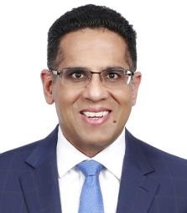  Kirindeep Singh  Senior Partner  Dentons Rodyk & Davidson LLP | Mr Kirindeep Singh is a senior partner in Dentons Rodyk’s Litigation & Dispute Resolution and Arbitration practice groups and is the Co-Head of the firm’s Construction practice. He was appointed by the Singapore Academy of Law as a Senior Accredited Specialist in Building & Construction Law in 2023. The accreditation scheme was introduced as a mark of recognition for a select group of legal practitioners who have gained professional excellence in their areas of practice.  Kirin's primary practice areas include construction and engineering, arbitration, civil and commercial litigation. In construction and engineering, Kirin has been involved in numerous disputes in adjudication, disputes boards, arbitration and litigation, both as counsel as well as adjudicator and arbitrator.  Kirin is recognised by various legal publications, including as a Leading Individual for Construction by Chambers Asia-Pacific and Litigation Star in Construction by Benchmark Litigation Asia-Pacific. He was also named in the Euromoney Guide to the World’s Leading Construction Lawyers (2nd Edition) for his construction practice.
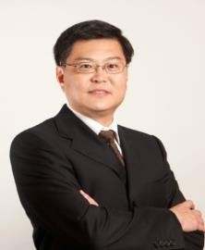  Edwin Lee Peng Khoon  Partner  Eldan Law LLP | Mr Edwin Lee is one of the founding partners of Eldan Law LLP, and a Senior Specialist in Construction Law.  He was cited as a leading Singapore construction law practitioner in Euromoney’s Guide to the World's Leading Construction Lawyers, as a distinguished practitioner in AsiaLaw, and by Doyles Guide as a leading Singapore lawyer for Construction Disputes Litigation and Arbitration.  Edwin has argued many of the landmark court cases on construction law, and on adjudications. Apart from his active legal practice, Edwin is also an Adjunct Associate Professor with the NUS, and SUTD, and a trainer for the BCA on Construction Law.  Edwin is the co-author of the books Confidentiality in Arbitration (2007) and Amendments to the SOP Act (2019), and is the author of Building Contract Law in Singapore (2016, 3rd Edition). He is also the Construction Law editor for the Singapore Academy of Law’s online journal SAL Practitioner.
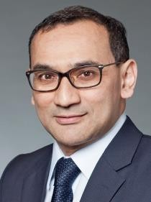  Ian De Vaz  Partner WongPartnership LLP | Mr Ian De Vaz is Head of WongPartnership’s Infrastructure, Construction & Engineering Practice and is a Partner in the International Arbitration, and Middle East Practices. He is an appointed Senior Accredited Specialist in Building and Construction Law by the Singapore Academy of Law.  As a dispute practitioner, Ian has extensive experience as lead counsel in both international and domestic construction arbitrations, dealing with various issues including delays, damages, loss and expense claims, defective works and design inadequacies, unforeseen ground and geotechnical conditions, and termination of contracts. He has particular expertise in land reclamation, infilling and soil improvement work, handling claims for damage to cable and underground services and in defending prosecutions under the relevant legislation, including on workplace safety & health matters.  Ian is recommended for his expertise in Projects & Energy and Construction in leading legal publications like Chambers and The Legal 500. He is also recognised as “Lawyer of the Year”  by Best Lawyers.

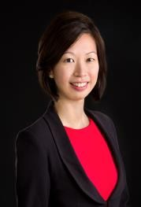  Yvonne Foo  Partner  Harry Elias Partnership LLP | Ms Yvonne Foo is a Partner in Harry Elias Partnership LLP’s specialist Construction and Engineering and, Energy and Infrastructure practice groups. She is an advocate and solicitor of the Supreme Court of Singapore, Fellow of the Chartered Institute of Arbitrators (FCIArb), and an associate mediator with the Singapore Mediation Centre. With extensive experience in advising international, regional and local clients on construction-related disputes, Yvonne routinely assists her clients on a wide range of claims and issues, including most recently, COVID-related issues. She also assists with the review, drafting and negotiation of construction contracts. Yvonne has been consistently ranked by various leading legal directories and independent publications, including most recently by The Legal 500 (Legalese) Asia Pacific (Next Generation Partner 2023), Chambers and Partners Asia-Pacific (Up and Coming Lawyer in Construction 2023), Asialaw Profiles (Notable Practitioner in Construction 2023), Benchmark Litigation Asia-Pacific (Future Star in Construction 2023) and Doyle’s Guide (Recommended Practitioner in Construction Litigation 2022).
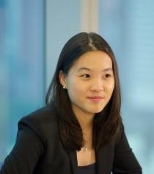  Chow Wen Si  Senior Legal Counsel Mott MacDonald Group | Ms Chow Wen Si is currently a Senior Legal Counsel with Mott MacDonald, a global engineering, management and development consultancy with 19,000 staff and a worldwide reach spanning six continents. After graduating from the University of Bristol, Wen Si worked at leading domestic and international law firms, where she specialised in infrastructure, construction and engineering matters, acquiring extensive cross-border and high-value disputes and front-end experience during her time there. Having moved in-house, Wen Si covers both local and international portfolios and provides trusted strategic advice to key stakeholders globally across a wide range of matters. Wen Si is an Advocate and Solicitor of the Supreme Court of Singapore and is the co-author of Adjudication – Case Law Principles. She is effectively bilingual in English and Mandarin and also has a working knowledge of German.
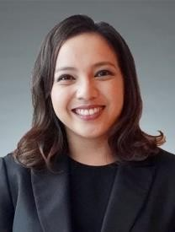  Monisha Cheong  Partner WongPartnership LLP | Ms Monisha Cheong is a Partner in WongPartnership’s Commercial & Corporate Disputes Practice. She has an active disputes practice and regularly appears before all levels of the Singapore Courts, international arbitral tribunals under various rules and in statutory adjudications. She is fluent in English, Mandarin and French and has represented clients in a wide range of complex, high-value and cross-border matters involving the private equity, construction, cryptocurrency, property, hospitality, renewable energy, automobile, natural resources and healthcare industries. Monisha is presently serving her second term as a member of both the YSIAC Committee as well as the Law Society of Singapore’s Building and Construction Law Committee. In addition to her counsel and advisory work, Monisha also sits as arbitrator. Monisha is a Contributing Editor of the Singapore “White Book” (Singapore Civil Procedure) 2022 on Order 3 (General Matters) and Security of Payments and Construction Adjudication (3rd Edition) by Chow Kok Fong. She is admitted to the Singapore Bar and the  Roll of Solicitors of England & Wales.

In the construction industry, arbitration is the major means of dispute resolution, particularly for large, complex projects. This new book addresses the process from the perspectives of both the parties involved and that of their advisers. It discusses ways to improve results of the process and the management of costs and time and a purposive approach to manage a construction arbitration.
Chow Kok Fong
Construction Arbitration
With a Foreword by
Justice Dato’ Mary Lim, Judge of the Federal Court of Malaysia

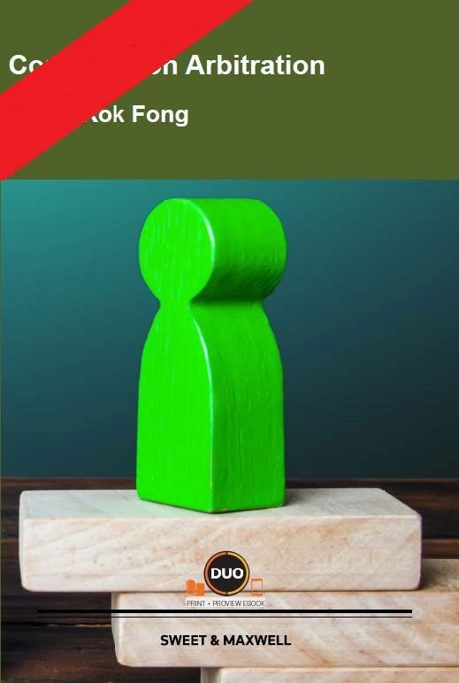
The construction industry on both sides of the Causeway and beyond are so much enriched by all his works, especially this latest masterpiece… Justice Dato’ Mary Lim, Federal Court of Malaysia

…another tour-de-force… an enormousassistance to those who want to know how construction arbitrations really work… Cyril Chern, Author of “Chern on Dispute Boards”

“…Chow Kok Fong has produced another excellent publication that furthercementshisstatusas an undisputed doyen of Singapore construction law.” Giam Chin Toon SC, Chairman Wee Swee Teow LLP and former Ambassador of Singapore to Peru

Available Sept 2023

How to order
W
www.sweetandmaxwellasia.com.sg E csd- SoutheastAsia@thomsonreuters.com

Book (Print & ProView)*
ISBN: 978 981 18 7263 1
$298 incl. GST
$258 incl. GST
*Early bird offer valid till 17 Nov

ProView eBook only*
ISBN: 978 981 18 7264 8
$219 incl. GST
$200 incl. GST
*Early bird offer valid till 17 Nov

Chow Kok Fong
Construction Arbitration
Contents
Among the 16 chapters are chapters discussing –
- Commencement Matters (Chapter 3) – development of the case theory and selection of the arbitrator.
- Conduct of Proceedings (Chapter 4) – management of procedural matters and documents.
- Management of Costs in Arbitration (Chapter 5) – managing costs and cost savings considerations.
- Documents and Evidence (Chapter 6) –gathering and organisation of evidence, requests for production and hearing bundles.
- Statements and Pleadings (Chapter 7) – drafting approaches to cause papers, pleadings and the memorials approach.
- Factual Witnesses (Chapter 8) – selection of witnesses, drafting of witness statements and preparations for examination.
- Expert Evidence (Chapter 9) –selection of experts, instructing the expert, presentation of expert evidence.
- Payments and Variations (Chapter 11); Delays and Extensions of Time (Chapter 12) and
Termination (Chapter 13)
Other chapters contain discussions on Arbitration Agreement and Construction Standard Forms (Chapter 2); Written Submissions (Chapter 10); The Award (Chapter 14); Interim Measures (Chapter 15) and Other Modes of Dispute Resolution (Chapter 16)
About the author

CHOW KOK FONG, PBM is a Chartered Arbitrator and a Fellow of the International Academy of Construction Lawyers. He was previously CEO of Changi Airports International and the Construction Industry Development Board and has held other senior appointments with major construction and real estate companies. He founded the Society of Project Managers and was past Chairman of the Society of Construction Law. Among his 21 books are Law and Practice of Construction Contracts (5 editions); Security of Payments and Construction Adjudication (3 editions) and the volume on building and construction law of Halsbury’s Laws of Singapore. He chaired the Ministry of Law working group drafting the Singapore Infrastructure Dispute Protocol which was published in 2018. He was awarded the Singapore Academy of Law Merit Award 2013 for contributions in promoting and advancing the development of Singapore law.

